Network System Design for an Organization
Name
Institution
FractalApps’ Requirements
It is essential for a network designer to first consider the requirements of an organization before making the final decisions of the type of network to design (Aros, Susan & Deborah, 2018). This will help in developing a customized network that would lead to maximum benefits to the organization. FractalApps is a software startup seeking to become a fully-fledged software development company. In this case, following the recent influx of funds from a financial angel investor, FractalApps seeks to design both LAN and WAN that will connect the three offices located in DC (headquarters), Brooklyn (sales office) and San Francisco (development house). FractalApps main concern is cost and security of the network design. The created WAN system has to be cost-effective and efficient enough to allow all of their staff to communicate and collaborate quickly, efficiently, without a lot of network delay.
At the moment, FractalApps is mainly used by job seekers. However, the founders’ attention has changed, and the company now aims at becoming a fully-furnished software developing company. In this case, the costs of the network design will include a future projection of the network needs, so that the established network does not lead to unexpectedly high costs in the short-run. Since the company does not need the network design to be costly, it is vital to avoid complicated network design. However, the network design should be able to support the expected traffic of the company (Oppenheimer, 2011). In the future, it is expected that FractalApps will have more users since it is becoming a software development company. Consequently, the network to be developed will be the one with sufficient capacity of effectively performing during the peak hours without breakdowns.
Network Design
From the case study facts, FractalApps is interested in a network design that will ensure that there is adaptability (due to expected growth in the future), flexibility, and improved fault isolation as well as saving costs. In this case, the network design technique utilized will be a hierarchical network model. A hierarchical network design refers to a three-layered network design which is applicable in the designing of both a LAN and a WAN network (Oppenheimer, 2011). In the hierarchical model, the company networks will be built into discrete layers, which consist of the interrelated components, categorized into three categories of Core, Distribution, and Access. In this regard, the hierarchical model to be utilized in the network design will be as follows
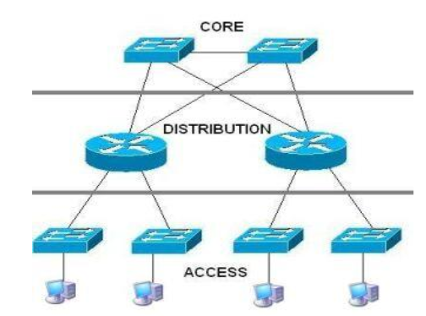
From the above model, each layer will perform its distinct functions, which will help in ensuring the final process performs efficiently. The core layer, which is a high-speed switching backbone of the entire system will be responsible for the interconnection of the distribution layers’ devices. In this layer, the traffic from all the distribution devices will be aggregated, whereby a large amount of data are forwarded to their specific destinations at high speed (Oppenheimer, 2011). Increasing the rate of data forwarding at this level will require network design to avoid packet filtering and other policy-based configurations that lead to unnecessary latency to the network system. Since the core layer is critical, hence the need for reliability and high fault-tolerant, a full mesh redundancy link between the core layer routers and between the distribution layer routers must be established. Since the company requires constant efficiency, it is necessary for FractalApps to have backup power supplies.
The distribution layer, which is between the access and core layer of the network model is the demarcation point between the two layers. The flow of traffic and access will be controlled at the distribution layer. Virtual LANs (VLANs) are designed at this layer, which will help in creating one or more broadcast domains as well as configuring the network devices that will be involved in the network like the routers for routing the IP Packets. The distribution layer is also essential as it helps in hiding the detailed topology information of the access layer from the core layer through address summarization, further improving the performance of the core layer.
The third layer, access layer, is crucial as it helps in connecting the local users to the network (Oppenheimer, 2011). In this case, the packets will be delivered to the end user computers using the access layer. The layer will also further help in ensuring that there is legitimate access to the network. The end devices like personal computers, printers and the IP phones that will enable FractalApps’ field agent to access the network services will be connected through the access layer.
Local Area Network and Its Components
The twisted cable will be used in the LAN for the three offices, which will be necessary in transporting communication from one end to the other. The figure below represents the twisted cable to be utilized
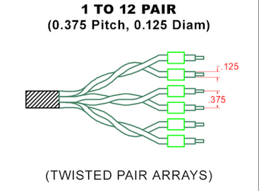
The resulting components of the LAN are represented in the diagram below

The four components of LAN are essential as they will help support the hierarchical model used. The Network stations will ensure collaboration of all the users, enabled by the use of devices like computers and the laptops. The network interface cards NIC and the drivers allow the ease of flow of communication across all the layers of the hierarchical model, hence sending and receipt of information to the computers having legitimate access to the network. The network operating systems of LAN for the core, distribution and access layer as it helps in managing all the resources of the proposed network so that each legitimate device that accesses the system gets what it requires from the FractalApps. Consequently, the resulting LAN diagram will be as follows
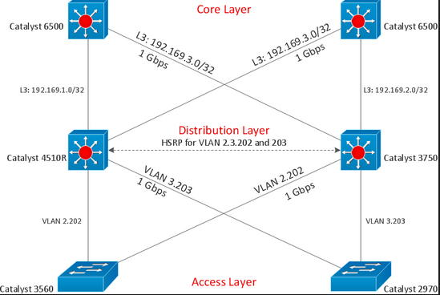
Since FractalApps’ need is to enable users to access the system even using a wireless system, the resulting diagram from the distribution layer through the access to the legitimate devices will be shown below, whereby a wireless LAN and wired LAN are joined together using a bridge to create a single LAN that is both cost effective and secured.
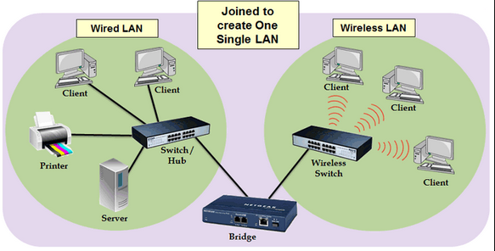

WAN and its Components
FractalApps requires a WAN system connecting the three offices as well as enabling field agents to access the system legitimately. Due to the need for seamless communication, the network will use at least 24GB RAM and 16-20 GB disk space. The base station will be located at the headquarters in DC, which will enable smooth switching. The Intel-based cards will be used due to their compatibility with the many devices. The resulting WAN system will be as follows from the hierarchical model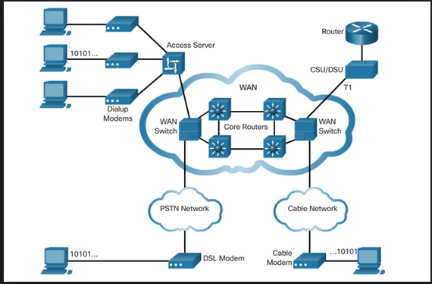
For security purposes, the resulting WAN network flow will be as follows, with the branches being the Brooklyn and San Francisco, whereas the DC being the DC headquarter. The resulting software-defined Wan implemented to the hierarchical model will appear as follows
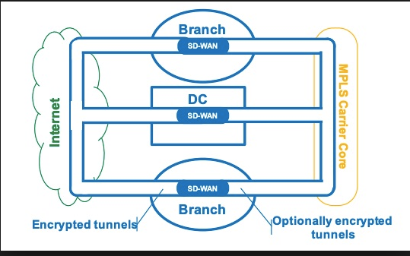

VPN
The need for security will require the use of VPN, which will protect the exchanged data from spying (Robba, Zammarchi & Grasso, 2018). Therefore, a PC from the two offices will be connected directly to the head office in DC. The OS of the several devices connected to the system will act as the VPN clients. A firewall will be installed to help in curtailing the extent of accessing the VPN servers, in turn avoiding the unauthorized access, hence addressing the security concern of FractalApps.

References
Aros, S. K., & Gibbons, D. E. (2018). Exploring communication media options in an inter-organizational disaster response coordination network using agent-based simulation. European Journal of Operational Research, 269(2), 451-465.
Mitra, A. (2016). Fundamentals of quality control and improvement. John Wiley & Sons.
Oppenheimer, P. (2011). Top-Down Network Design. Indianapolis, USA: Cisco Press; 2011.
Robba, M., Zammarchi, C., & Grasso, G. (2018). U.S. Patent No. 9,894,044. Washington, DC: U.S. Patent and Trademark Office.

